Power BI Assignment 1 – Data Transformation & Data Modeling

Screenshots of the solution and the data model view
Brief explanation of transformation and modeling logic

- Dataset import screenshots
  - Import List of Orders.csv into Power BI.
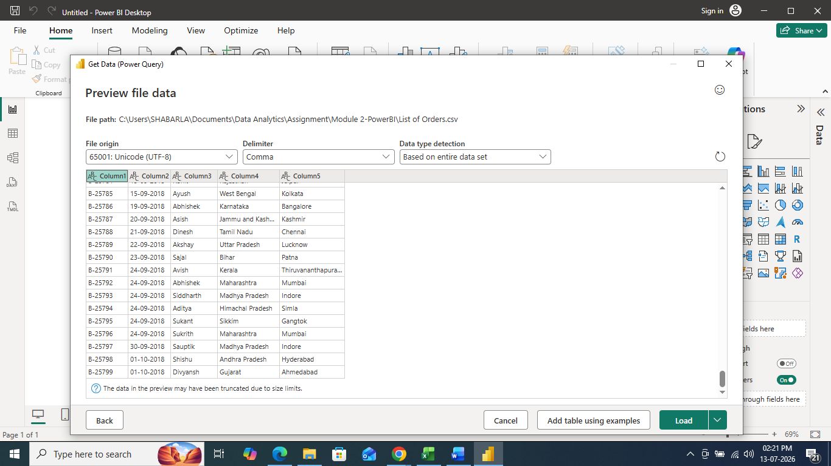

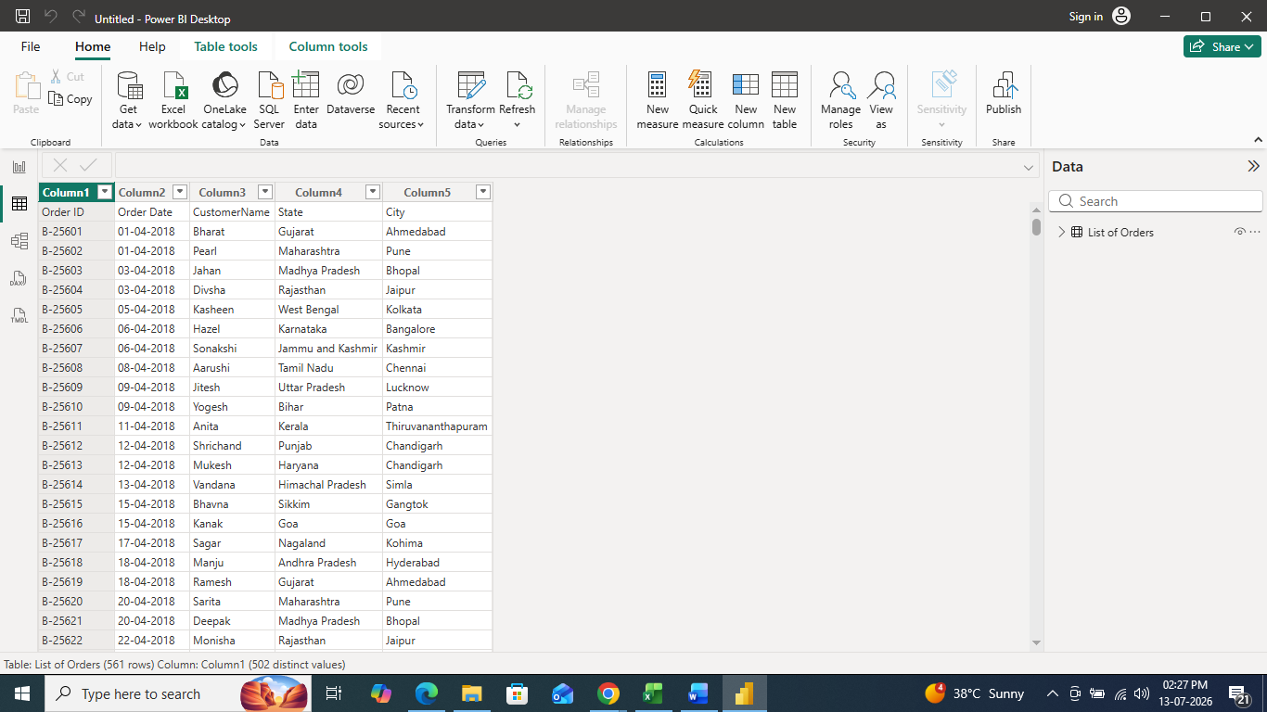

  - Open the list of orders in the Power Query Editor using the Transform Data option.

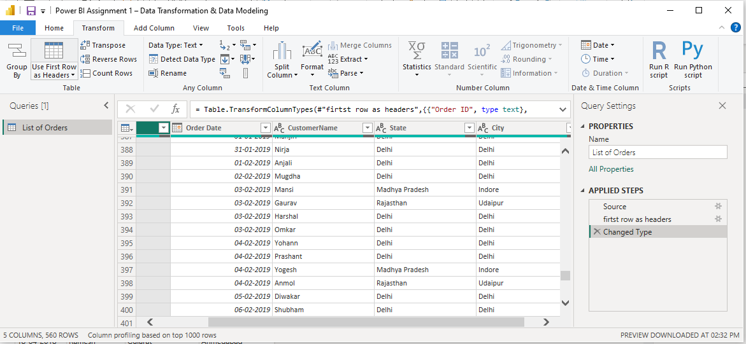

  - Import Order Details.csv and Sales Target.csv into Power Query Editor.
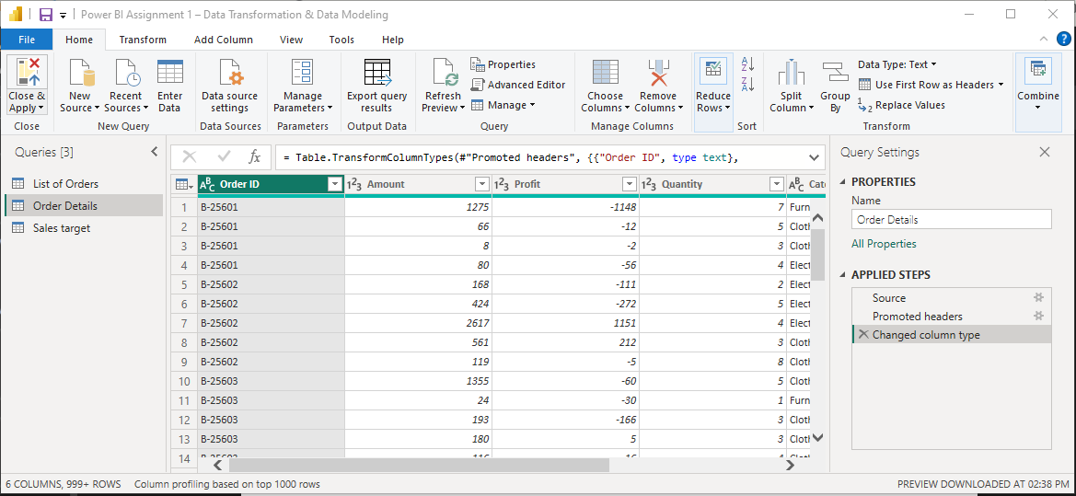



The three CSV files (List of Orders, Order Details, and Sales Target) were imported into Power BI using the Get Data feature. All datasets were opened in Power Query Editor to perform data cleansing and transformation before loading them into the data model.

- Row Limiting & Data Types
  - Restrict the List of Orders table to the first 500 rows

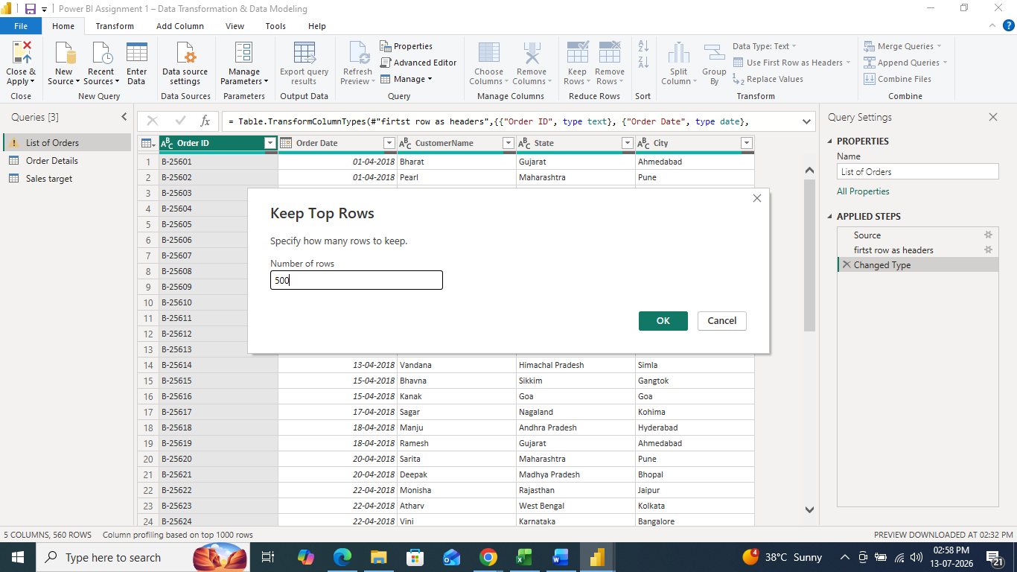

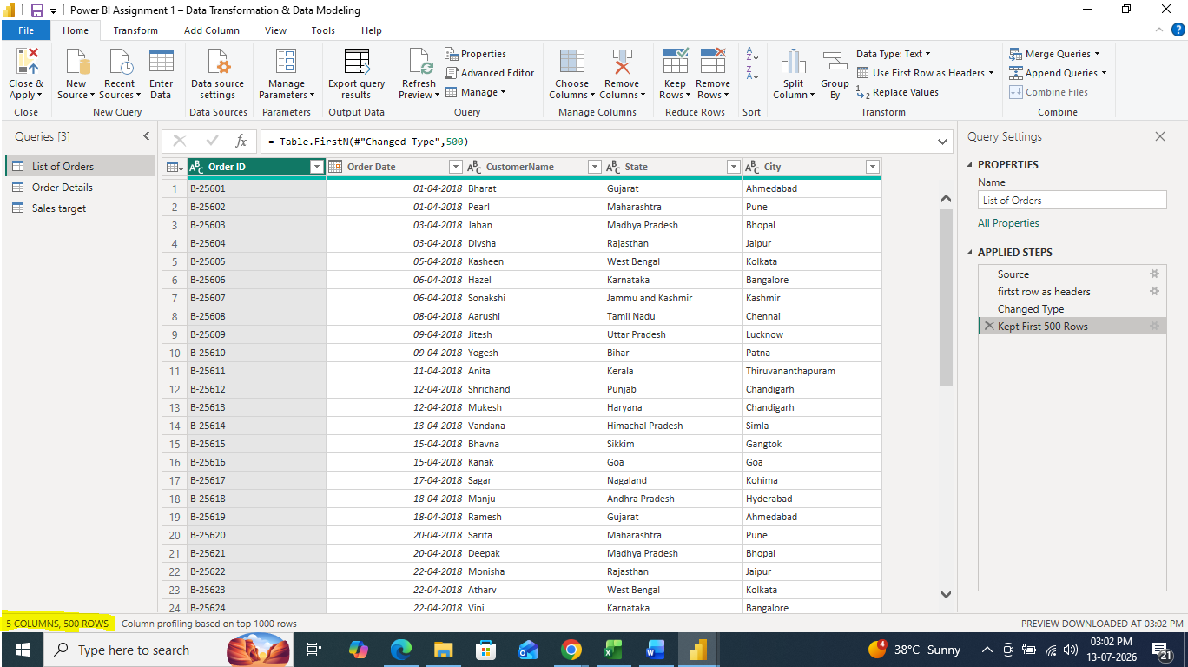

  - Set the Order Date column to the Date data type.
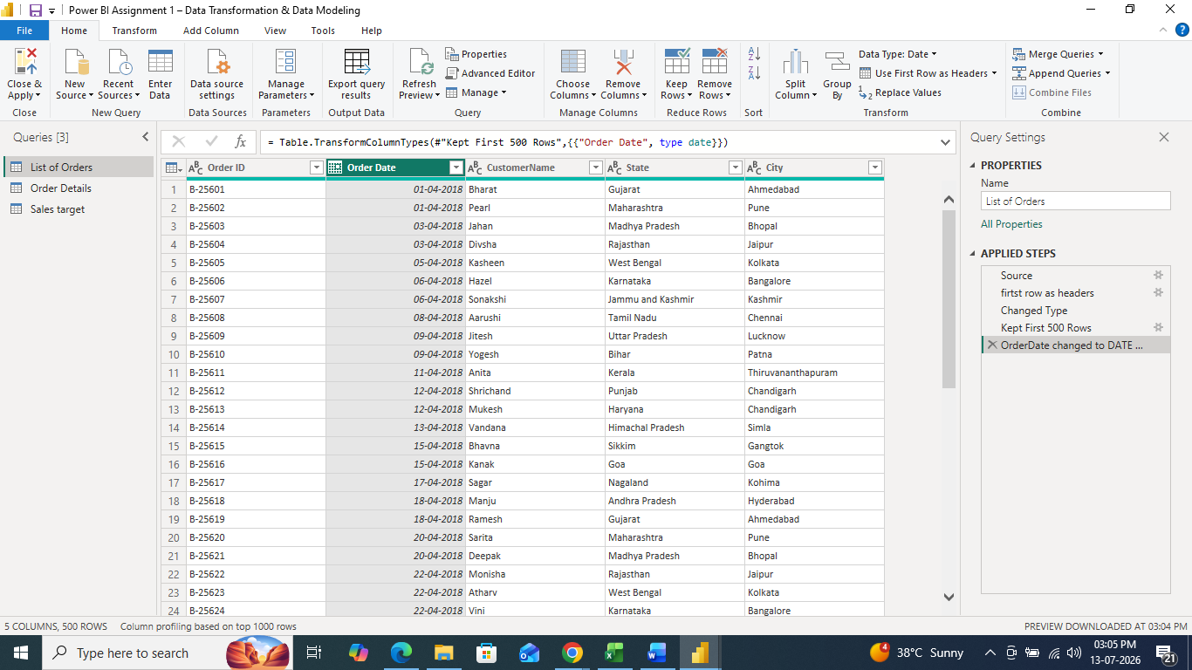
  - Change the Amount and Target columns to fixed decimal numbers.
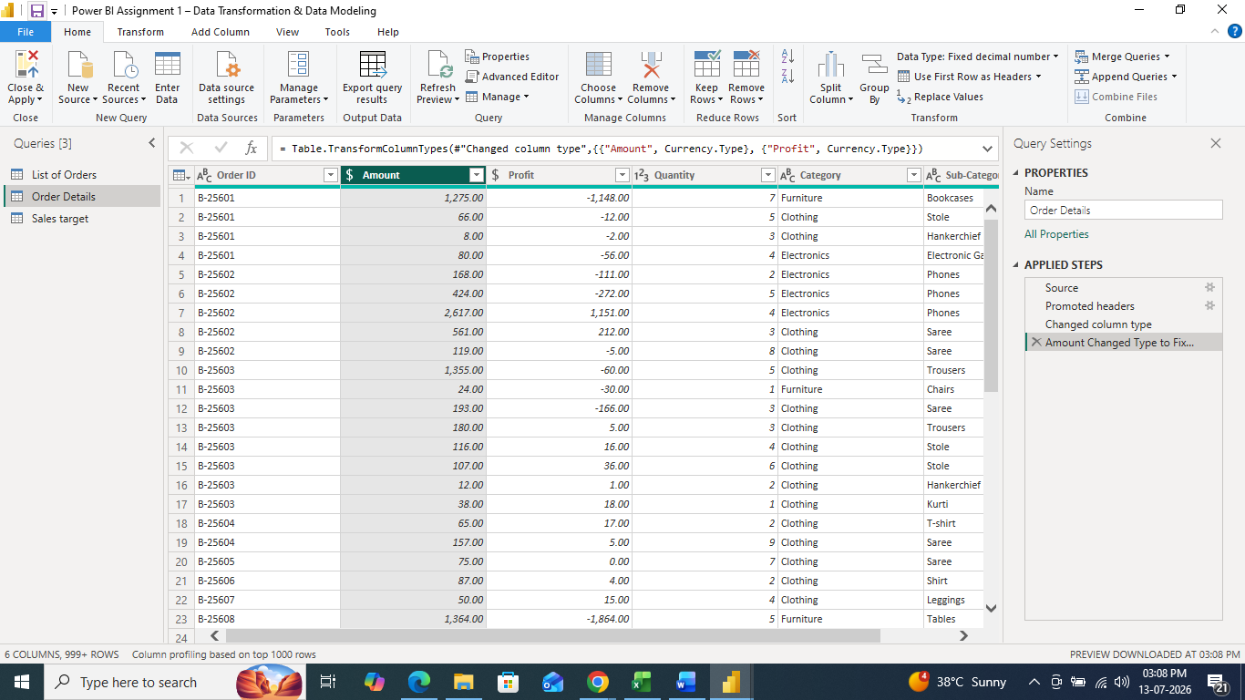

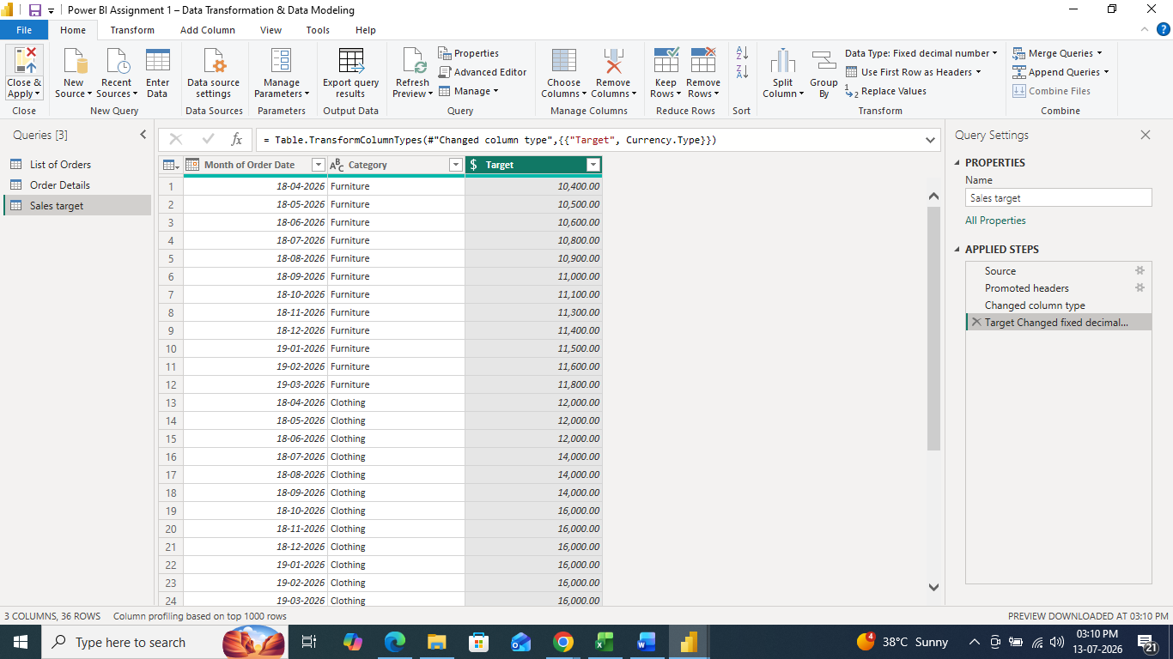

The List of Orders table was restricted to the first 500 rows to meet the assignment requirement. The Order Date column was converted to the Date data type to support accurate time-based analysis. The Amount and Target columns were converted to Fixed Decimal Number to ensure consistent numerical calculations.

- Text Formatting
  - Format the CustomerName column to proper case to ensure consistent capitalization
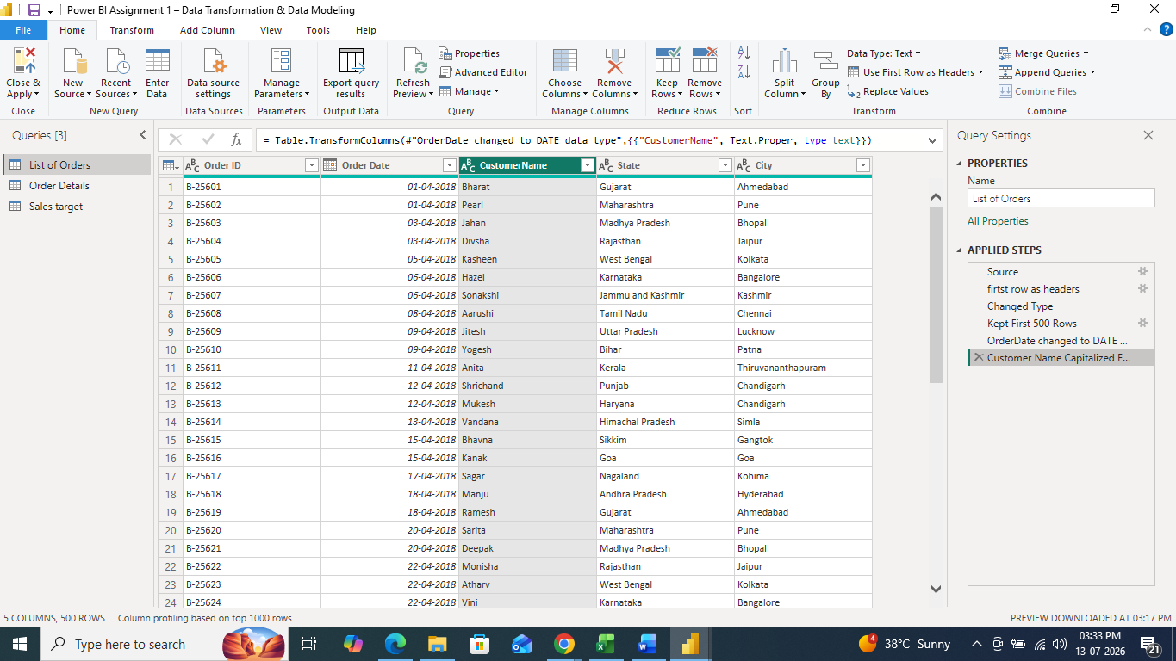

- Column Creation:
  - Merge the City and State columns to create a new column named Location in the format:
City, State

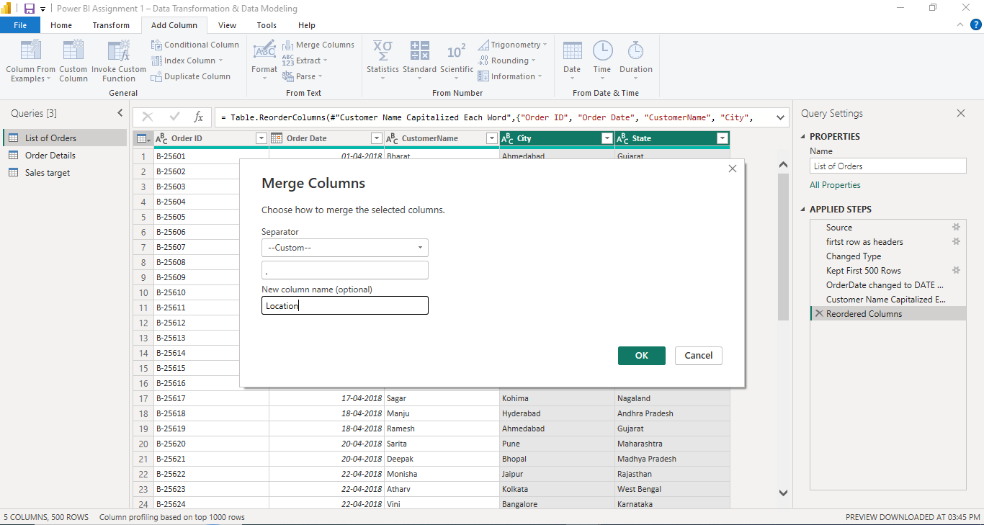
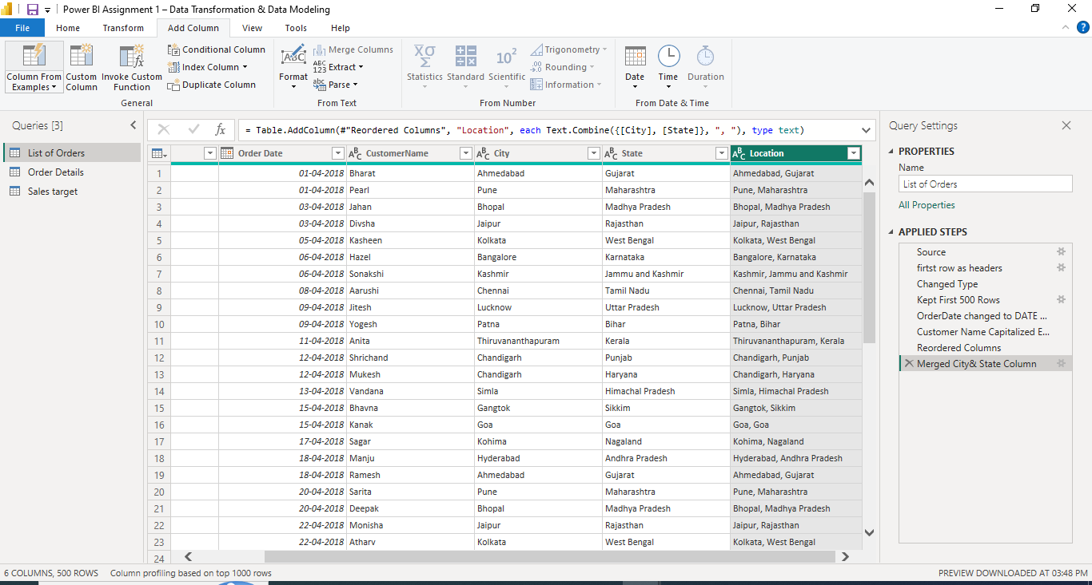

  - Create a custom column named Profit Margin calculated as: Profit / Amount (expressed as a percentage)
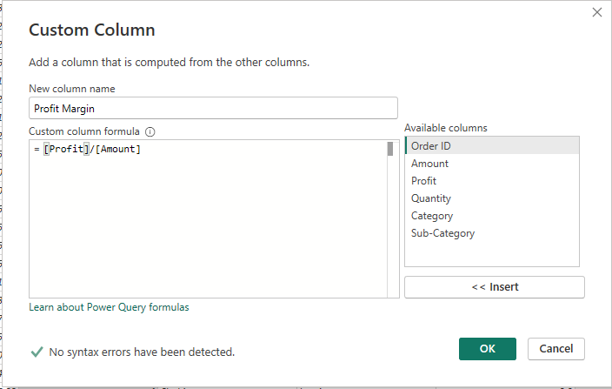

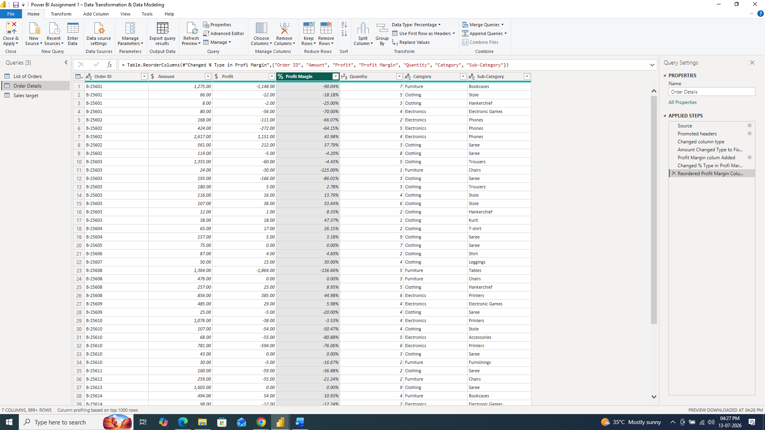

The Customer Name column was formatted to Proper Case to standardize text values and improve data consistency. A new Location column was created by merging the City and State columns into a single field in the format City, State, making geographical analysis easier.
A custom column named Profit Margin was created using the formula:
Profit Margin = Profit ÷ Amount
The result was formatted as a percentage to measure the profitability of each order.

- Conditional Column
  - Add a conditional column named Profit Status based on:
    - Profit < 0 → Loss , Profit = 0 → Break-Even, Profit > 0 → Profit
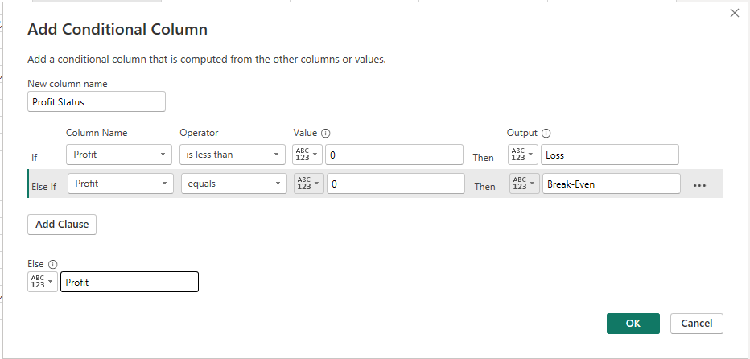
A conditional column named Profit Status was added using the following business rules:
- Profit < 0 → Loss
- Profit = 0 → Break-Even
- Profit > 0 → Profit
This categorizes each order based on its financial performance.
- Merging Data (Joins)
  - Merge the List of Orders and Order Details tables using Order ID.
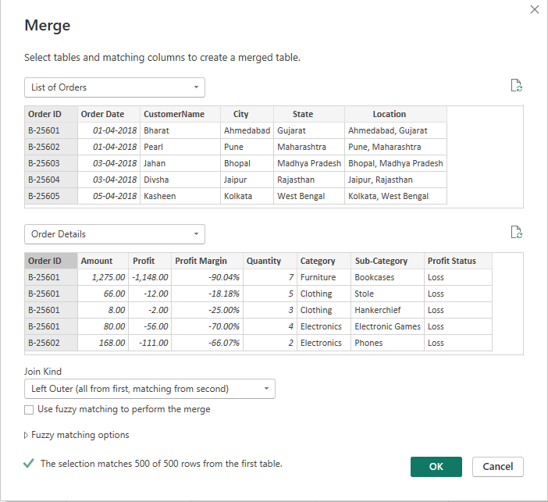
  - Name the merged output table as Orders Data.
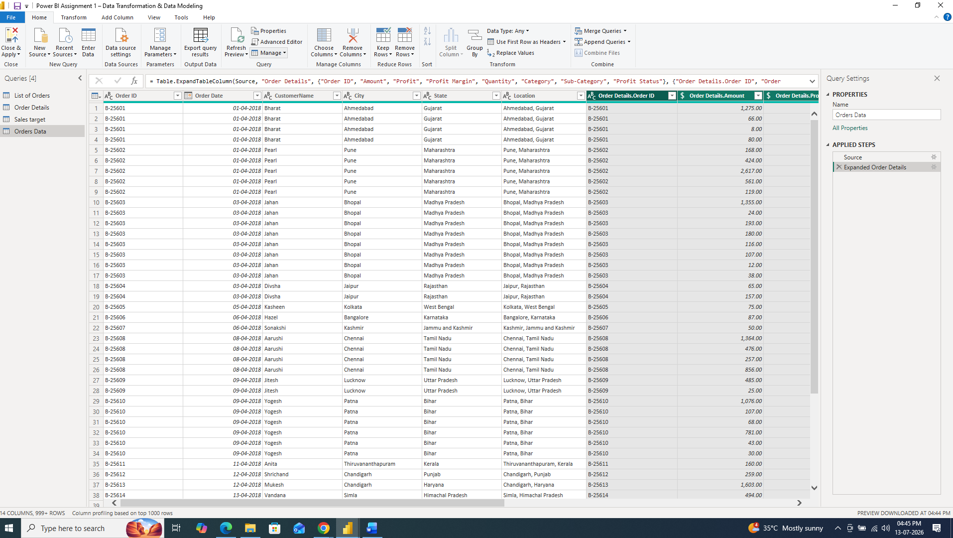
The List of Orders and Order Details tables were merged using the Order ID column with a Left Outer Join. The merged table was named Orders Data, providing a consolidated dataset containing both customer information and order details.

- Handling Missing Data & Duplicate Data
          - List of Order dataset contains 60 blank rows.
          - Already Restrict the List of Orders table to the first 500 rows.
          - Now no null values in the dataset
          - Order Details & Sales Target datasets have No missing values and No action required.
          - No Duplicate in all datasets

- Sorting and Filtering Data
  - Sort records in the Orders Data table by Order Date in descending order.
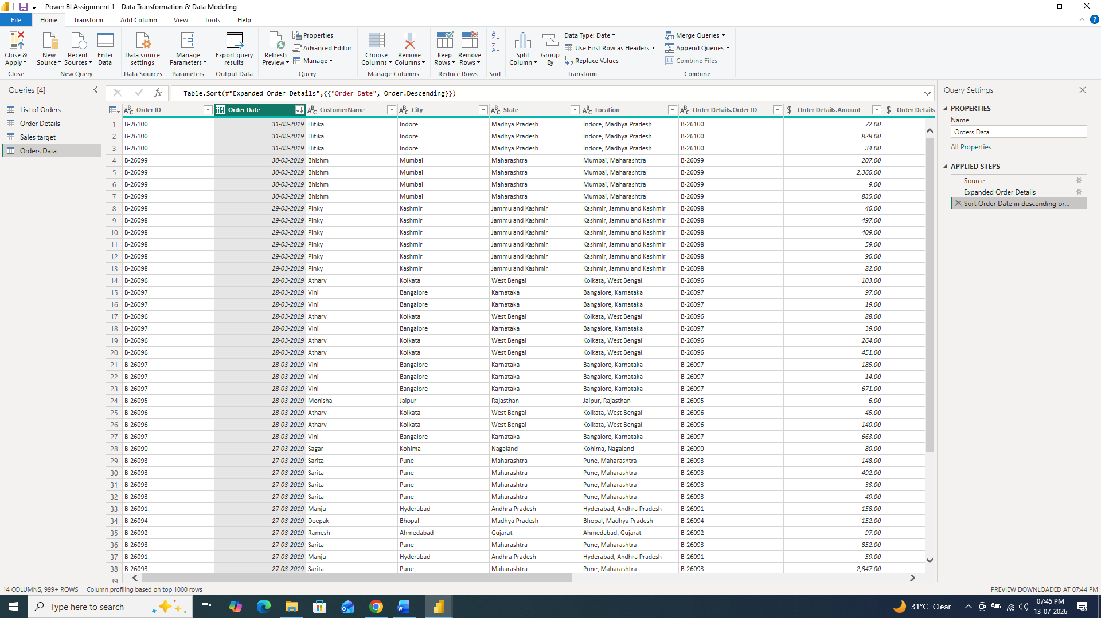

  - Apply filters to analyze orders from a specific state (e.g., Tamil Nadu).

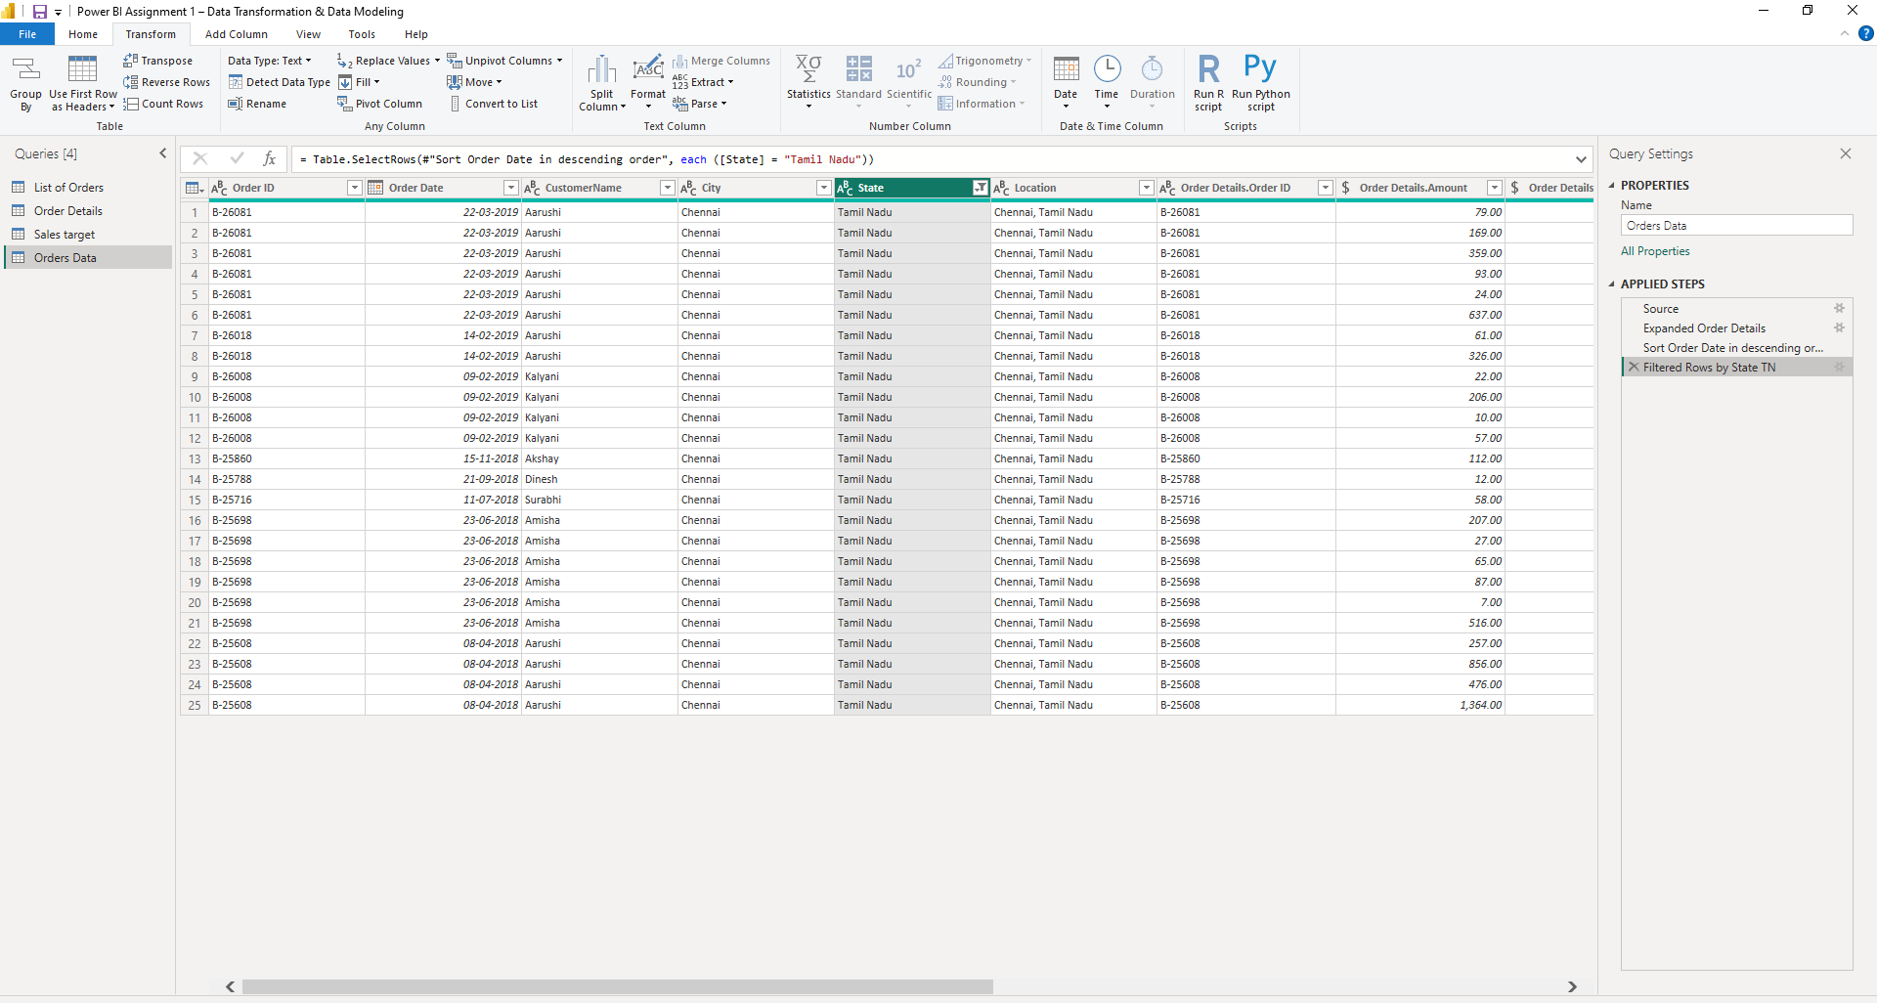
- Grouping and Aggregating Data
  - Duplicate the Order Details table
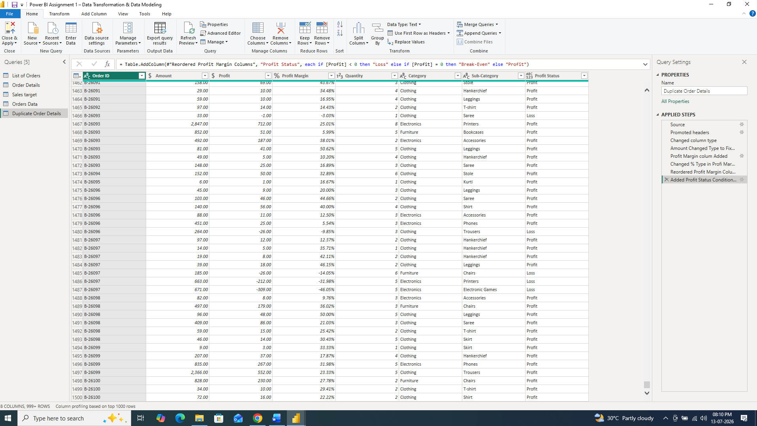

    - Count of Order ID

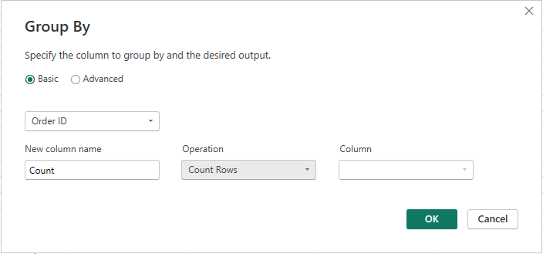
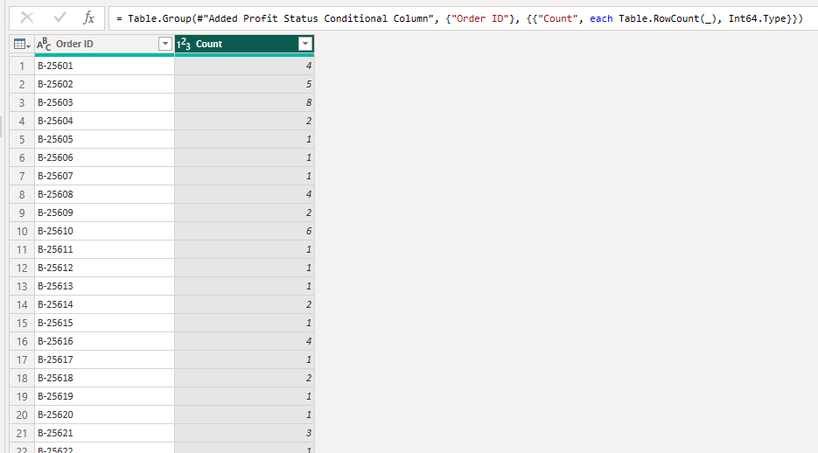

    - Average Profit by Category
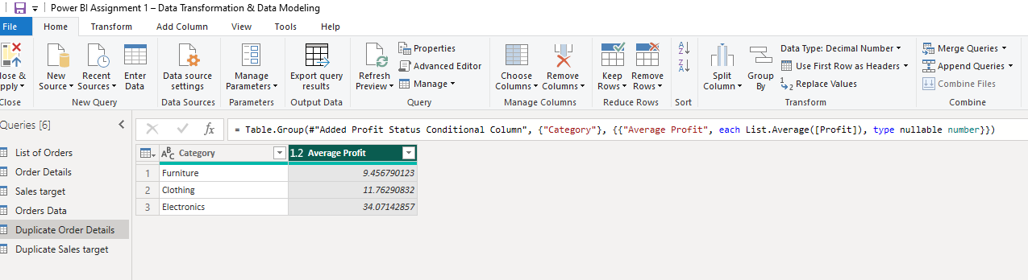

    - Total Amount by Sub-Category
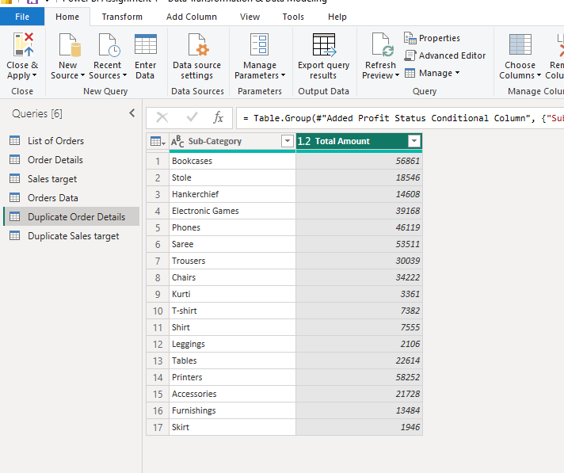
  - Duplicate the Sales Target table and aggregate the total Target by Month of order date.

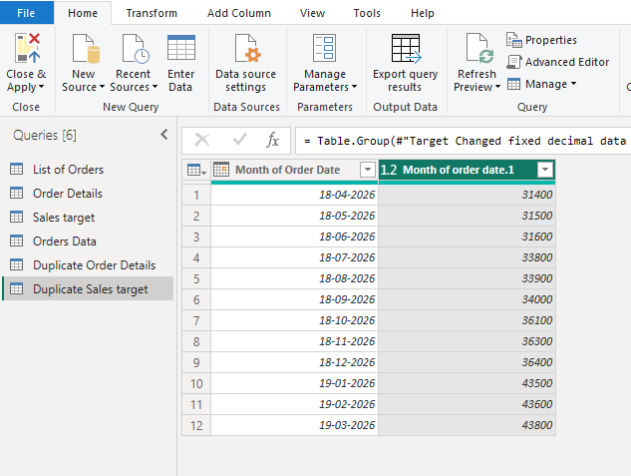

- Data Modeling
  - Establish a relationship between:
    - List of Orders and Order Details using Order ID
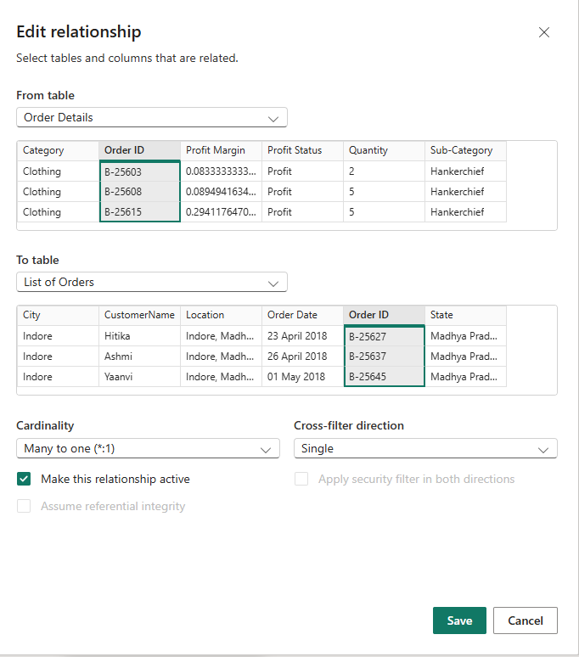

  - Establish a relationship between:
    - Order Details and Sales Target using Category
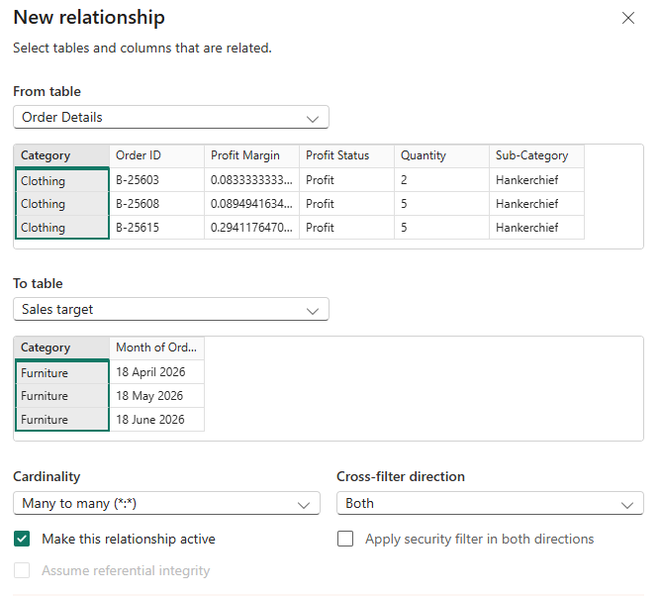

  - Use Manage Relationships to ensure relationships are active and correctly defined.
